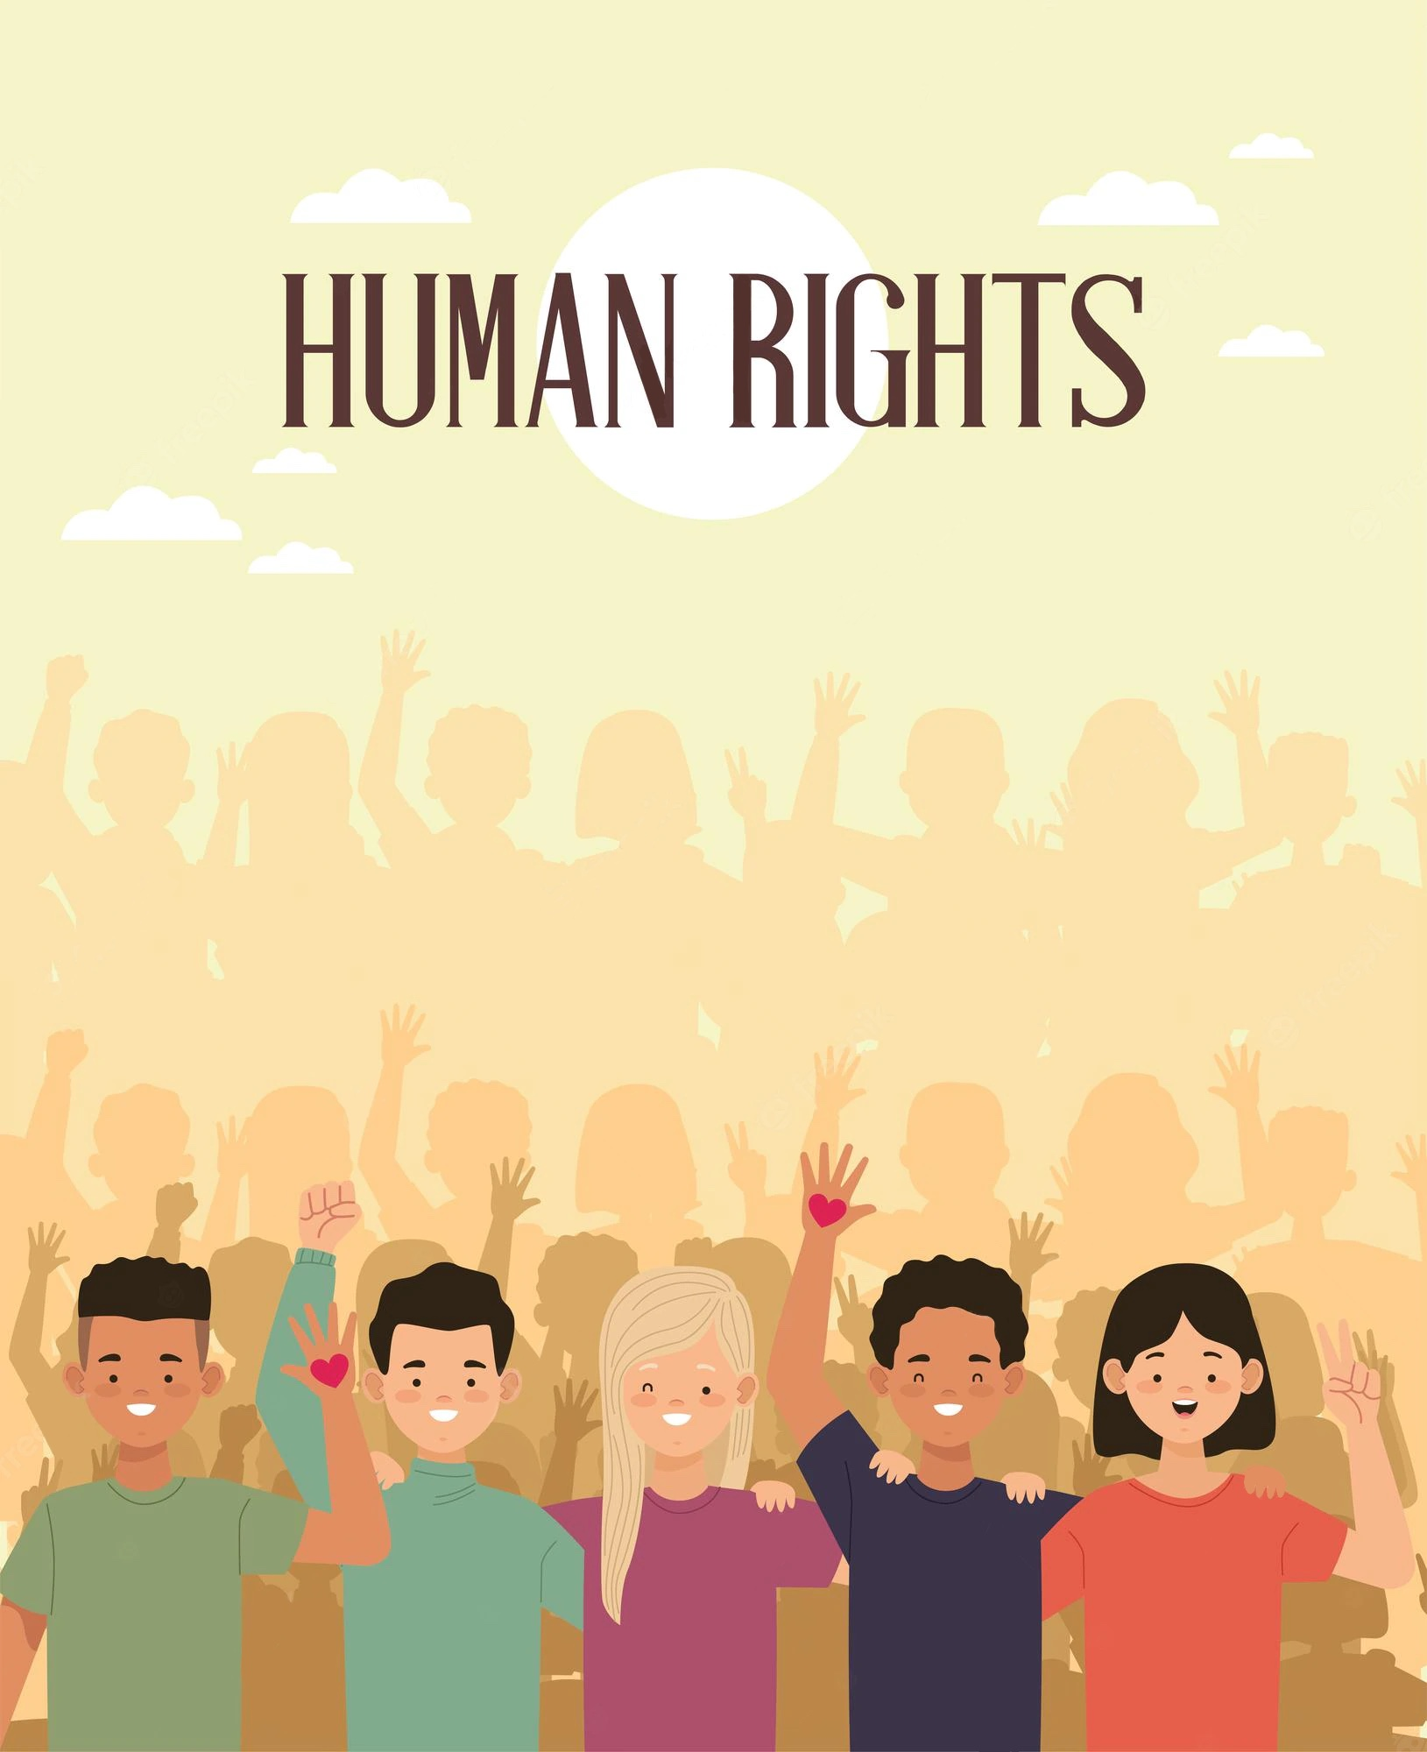
My
Portfolio
This portfolio
belongs to:
..........................................

What is this folder about?
In this folder you are going to learn about the Human Rights.
You will get to know the 30 articles of the declaration of Human Rights
and work with them in different ways. At the end of this folder you are going to
be an expert on the Human Rights and you will be more aware of how they
shape your everyday life.
Each task is marked with one of these symbols.
They stand for different kind of excercises:
Thinking and
Digital
reflecting
Communication
Information
you work alone
and think for yourself
Creativity
you work in pairs or
groups of three
Table of contents
page 3:
What do you already know about Human Rights?
What are Human Rights? A close-up
Keyword pictogrammes
pages 4-6:
page 7:
page 8:
page 9:
Keyword graffiti
Human Rights in your everyday life
The Fair - an exploration of Human Rights
I spy with my little eye..
Violation of rights
My Human Rights logo
Human Rights in the classroom
Methodical-didactical preparation and implementation
Sources; The LERI-Project
page 10:
page 11:
page 12:
page 13:
page 14:
page 16-18:
page 19:
2
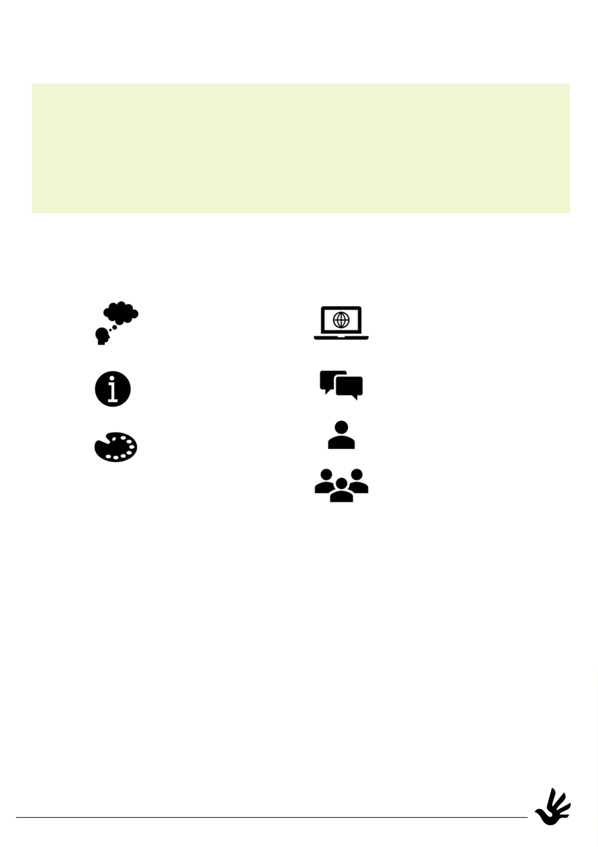

What do you already know about Human Rights?
You have probably already heard about Human Rights
and what they mean. What do you think of when you hear about them?
Try to find a word that is connected to the topic
for each letter of the word "Human Rights"!
E
Q
H U M A N R I G H T S
A
L
I
T
Y
Do you know some words in another language (maybe your mother
tongue) that are connected to the topic?
Write them down as you did above!
H U M A N R I G H T S
You can follow the QR-Code or link to the declaration of Human Rights
in your own mother tongue if you need help or inspiration.
https://tinyurl.com/4b
47yx3k
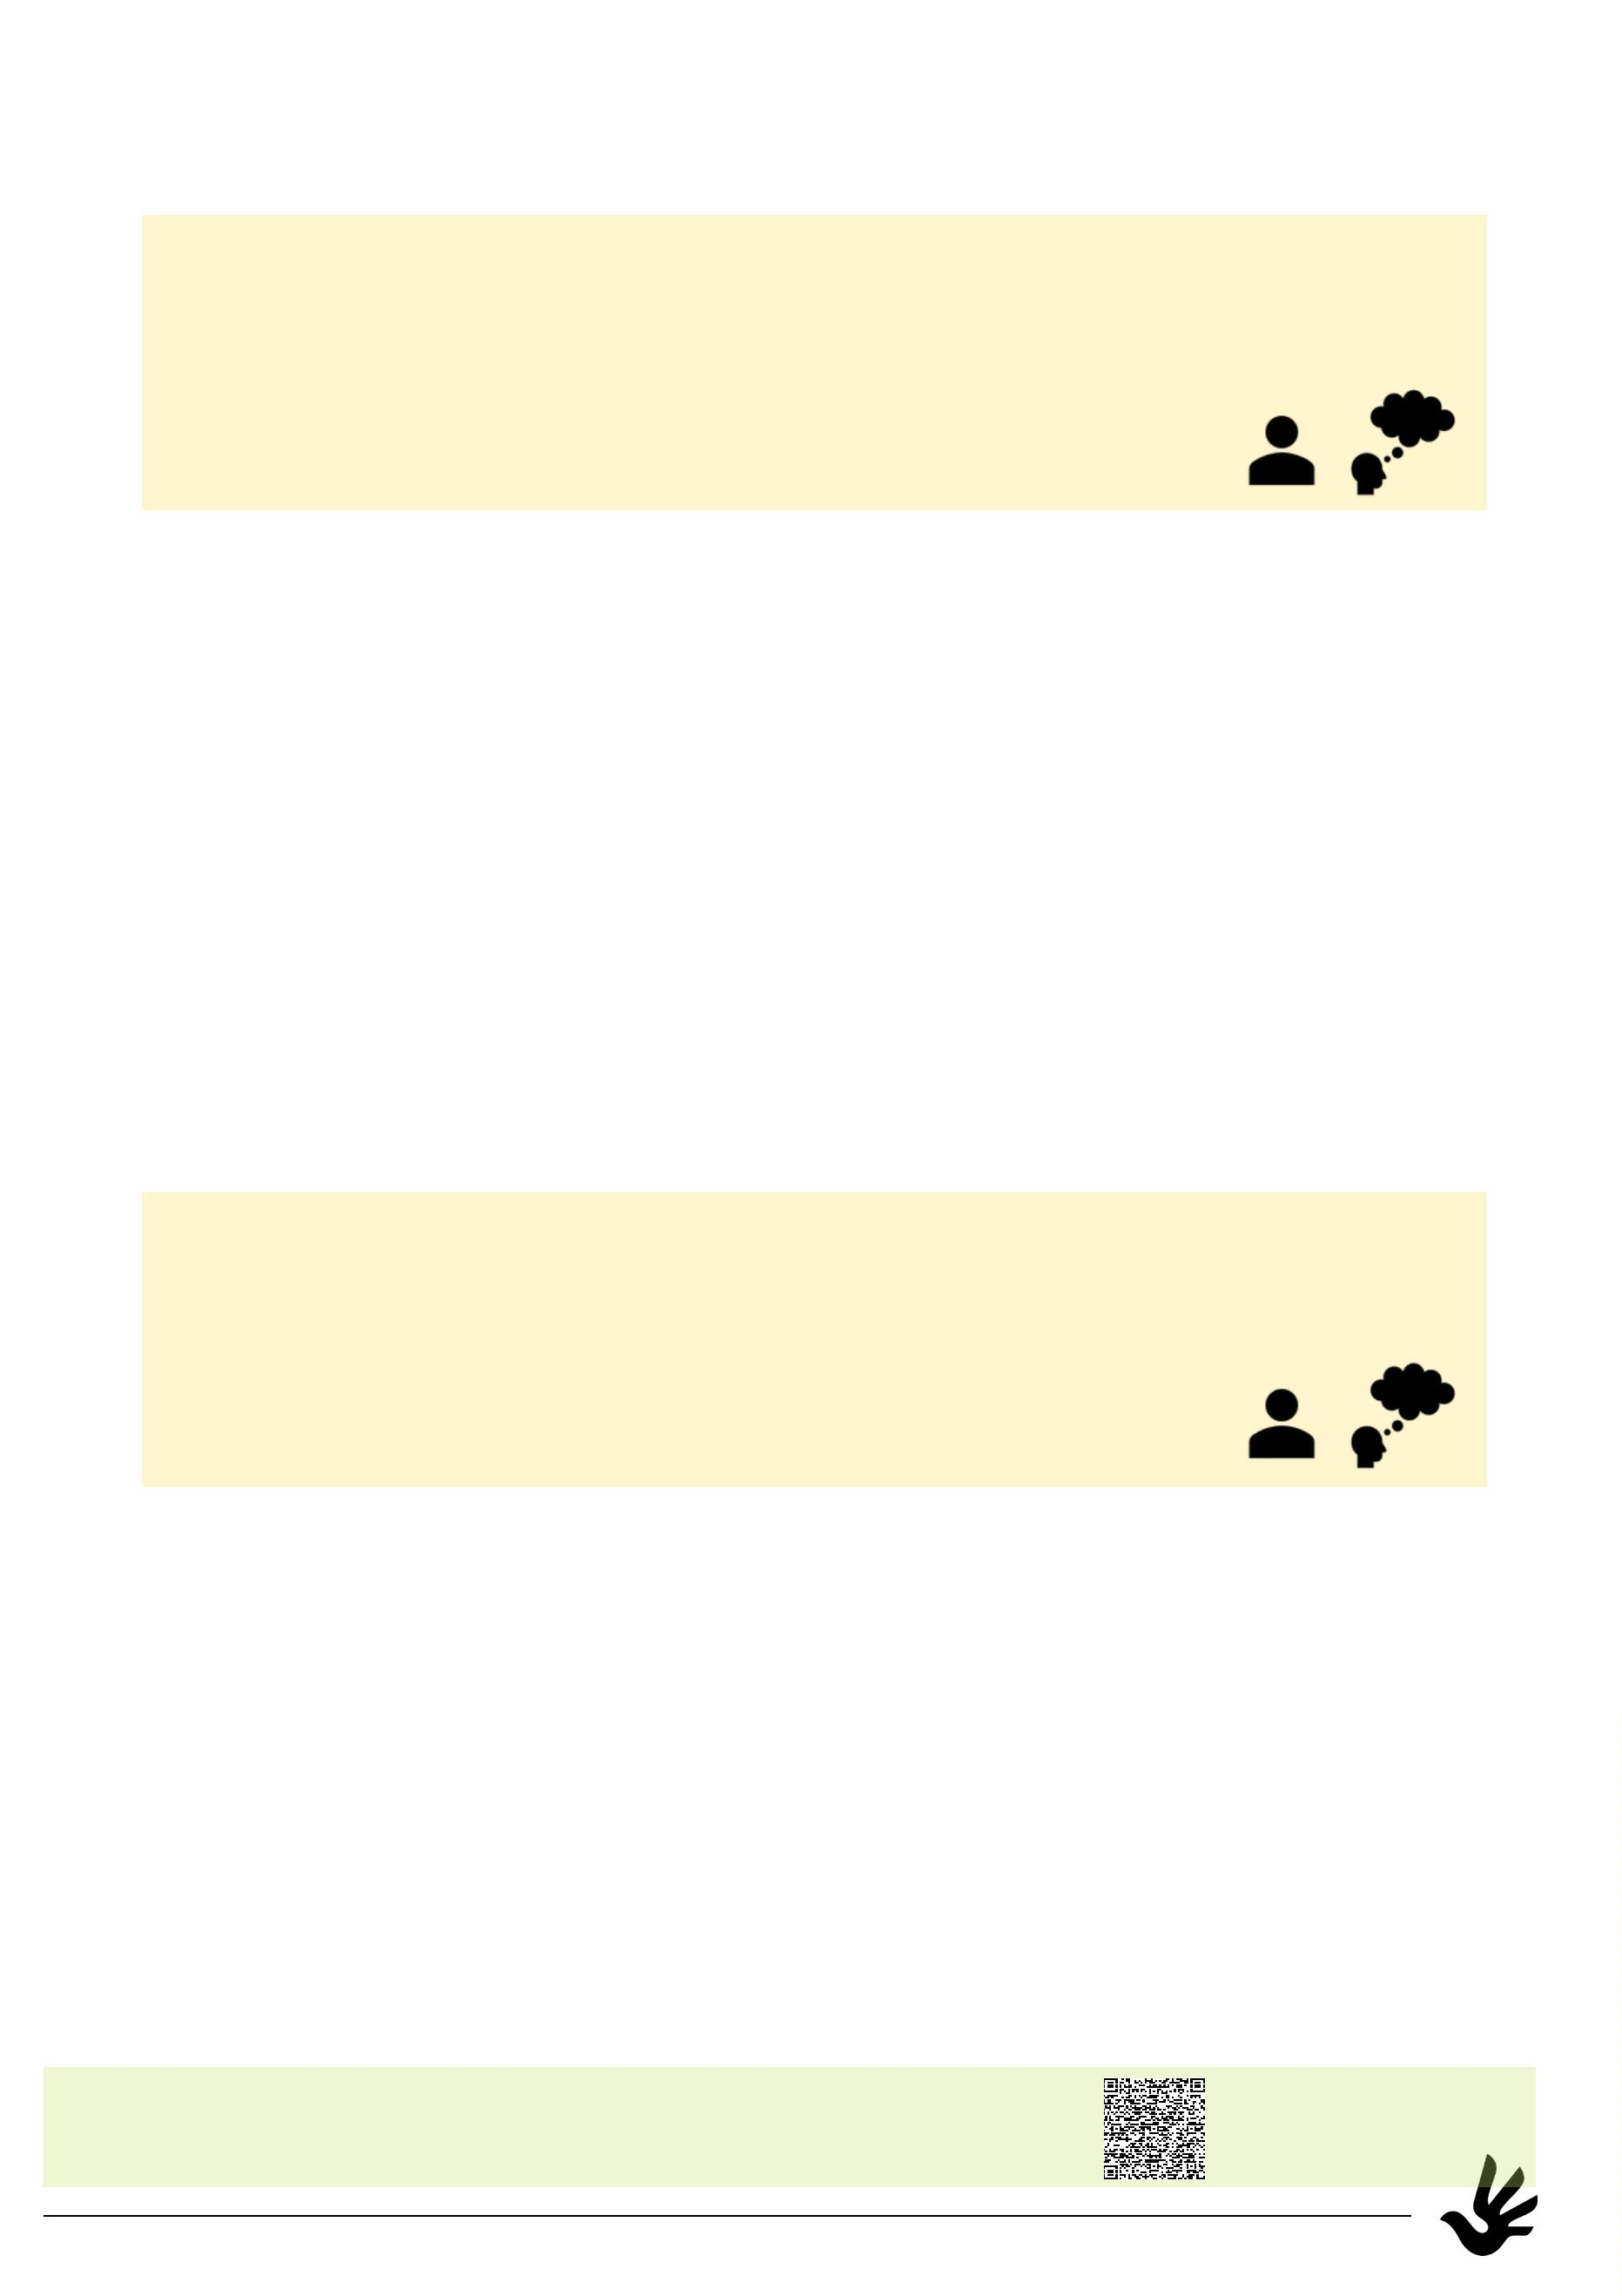

What are Human Rights? A close-up
All people everywhere have the same human rights which no one can take away.
This is the basis of freedom, justice and peace in the world.
The declaration of Human Rights see the dignity and worth of all people, and
the equal rights of women and men. The rights are the common
standard for all people everywhere. Every person and nation is asked to
support the understanding and respect for these rights, and to take steps to make sure
that they are recognised and observed everywhere, for all people.
Read the 30 articles of the declaration of Human Rights carefully. Find the most
important word in each article and write it down. If you think two words are very
important, write down a second one.
Article
What is this article about?
keywords
1
Everyone is born free and equal in dignity and with rights.
equal, dignity
You should never be discriminated against for any reason.
Rights belong to all people, our differences don't matter.
2
3
4
Everyone has the rights to life, liberty and security.
No‐one shall be held in slavery or servitude.
No‐one shall experience torture, inhuman or degrading
treatment or punishment.
5
6
7
8
9
You have the right to be treated as a person in the eyes of the
law.
You have the right to be treated by the law in the same way
as everyone else. Everyone has a right to protection.
If your rights under law are violated, you have the right to see
justice done in a court or tribunal.
No‐one shall be subject to arbitrary arrest, detention or exile.
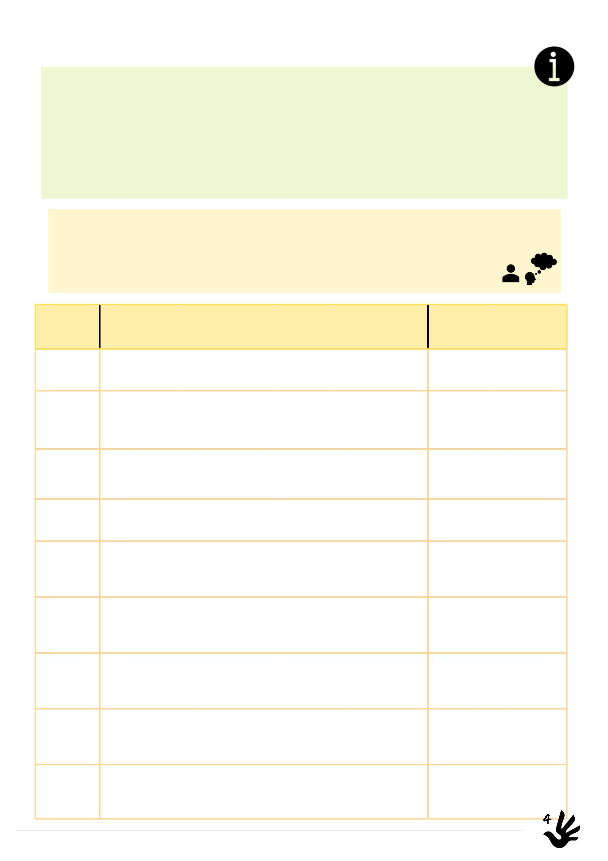

You have the right to a fair and public trial by an independent and impartial
tribunal.
1
0
1
1
Everyone is to be presumed innocent until proven guilty in a fair trial.
No‐one has the right to intrude in your private life or interfere with your
home and family without good reason. .
1
2
3
You have the right to freedom of movement within your country. Everyone
has the right to leave a country and to return home.
1
You have the right to seek and to enjoy asylum from persecution in other
countries. You may not invoke this right if fleeing just laws in your own
country.
14
15
16
You have the right to a nationality.
You have the right to marry and to raise a family. Men and women have the
same rights when they are married and when they are separated.
You have the right to own property and it cannot randomly be taken away
from you.
1
7
8
You have the right to freedom of thought, conscience and religion and to
peacefully express those beliefs in teaching, practice and worship.
1
19
20
21
22
You have the right to freedom of opinion and expression.
You have the right to freedom of peaceful assembly and association.
You have the right to take part in the government of your country.
As a member of society, you have a right to social security.
You have the right to work, to good working conditions, to equal pay for
equal work and to form and join unions.
23
5


24
25
26
27
You have the right to rest and leisure.
You have the right to a decent life, including enough food, clothing,
housing, medical care and social services.
You have the right to an education.
No‐one may stop you from participating in the cultural life of your
community.
You have the right to live in the kind of world where your rights
and freedoms are respected.
2
8
9
We all have a responsibility to the people around us and should
protect their rights and freedoms.
2
There is nothing in this declaration that justifies any person or
country taking away the rights to which we should have.
30
Follow the QR-Code or the link. You will get to see all
the translations of the Human Rights declaration.
Choose a language you are familiar with and write
down 10 keywords and their translation!
https://tinyurl.com
/
4b47yx3k
I chose this language: .................................................................
1
2
3
4
5
.
.
.
.
.
6.
7.
8.
9.
10.
6
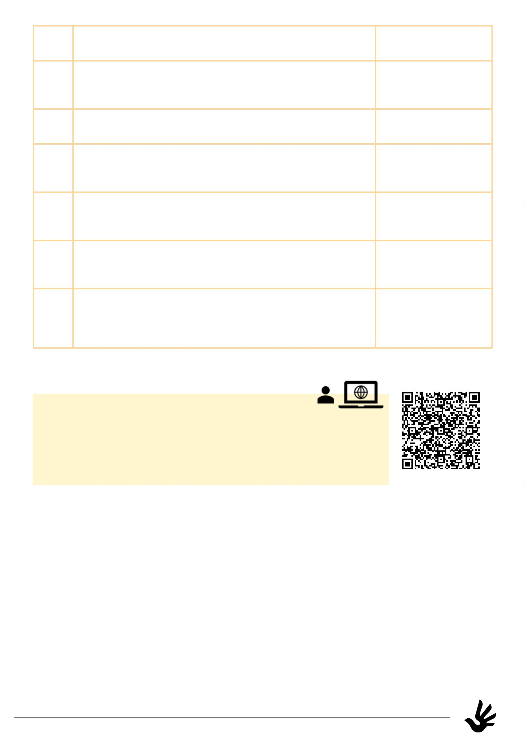

Keyword pictograms
Take a look at the keywords you found on pages 4-6.
Do you associate them with a picture or an icon?
Follow the QR-Code or link to flaticon.com and look up icons,
symbols or pictograms that stand for the keywords!
Choose 8 keywords and draw the pictogrammes!
A pictogram is a single symbol or icon that
provides an information through a simple picture,
for example:
https://www.flaticon.com
keyword
symbol/pictogram
keyword of article nr.1:
dignity
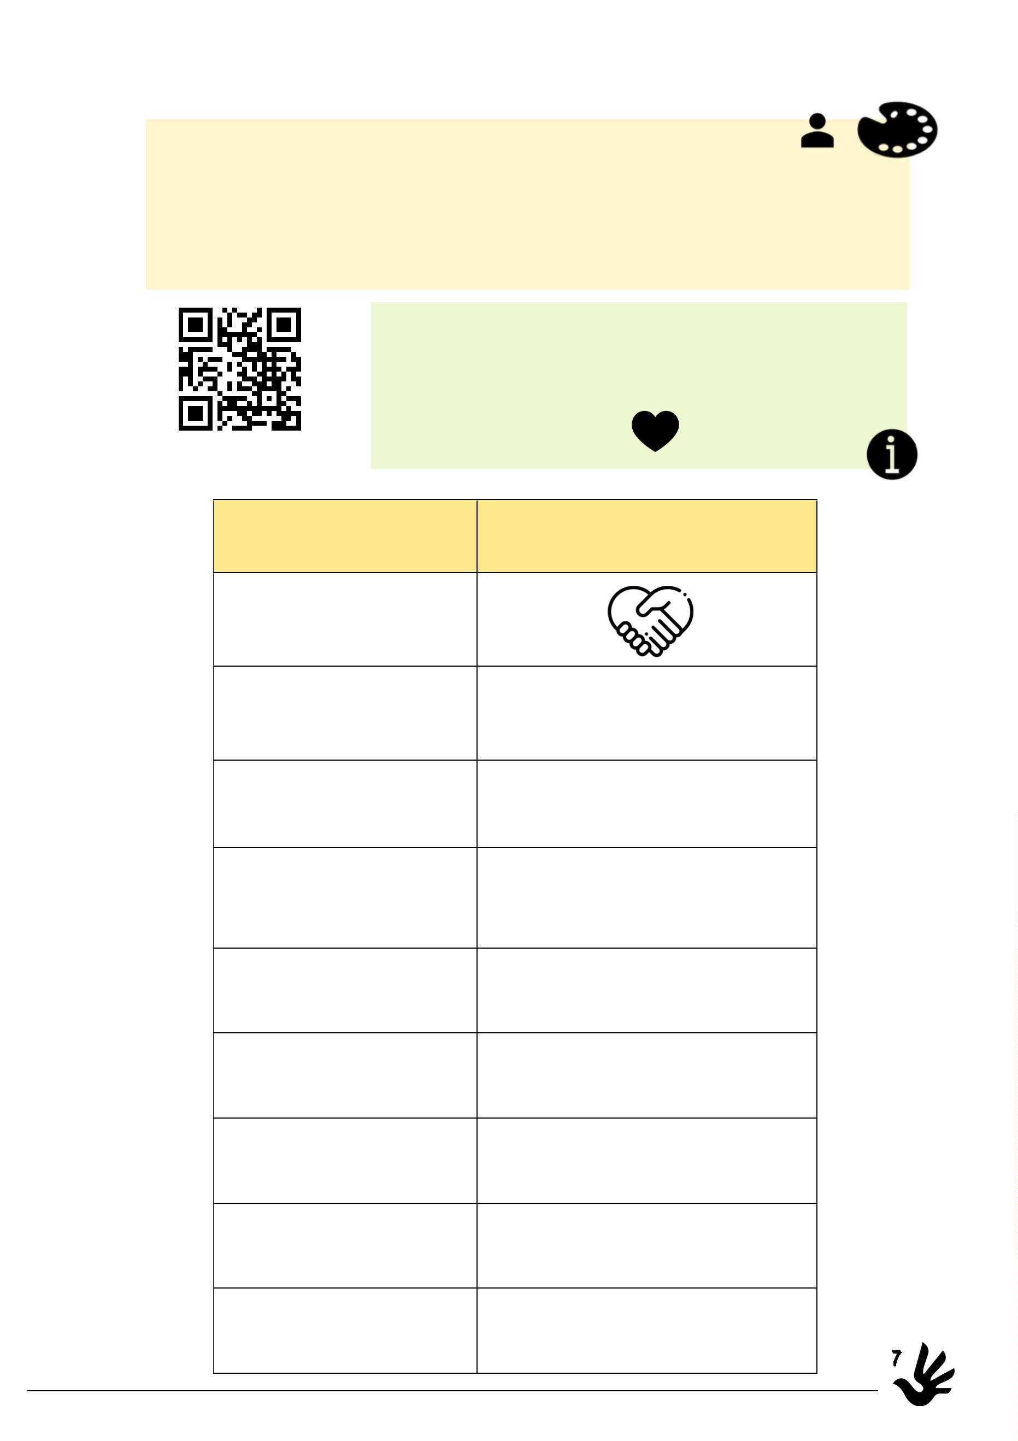

Keyword graffiti
You got to know some important information about
the Human Rights and what they are about.
Choose some keywords and design a graffiti wall with them!
Talk to your classmates to include words in their
mother tongues as well!
8
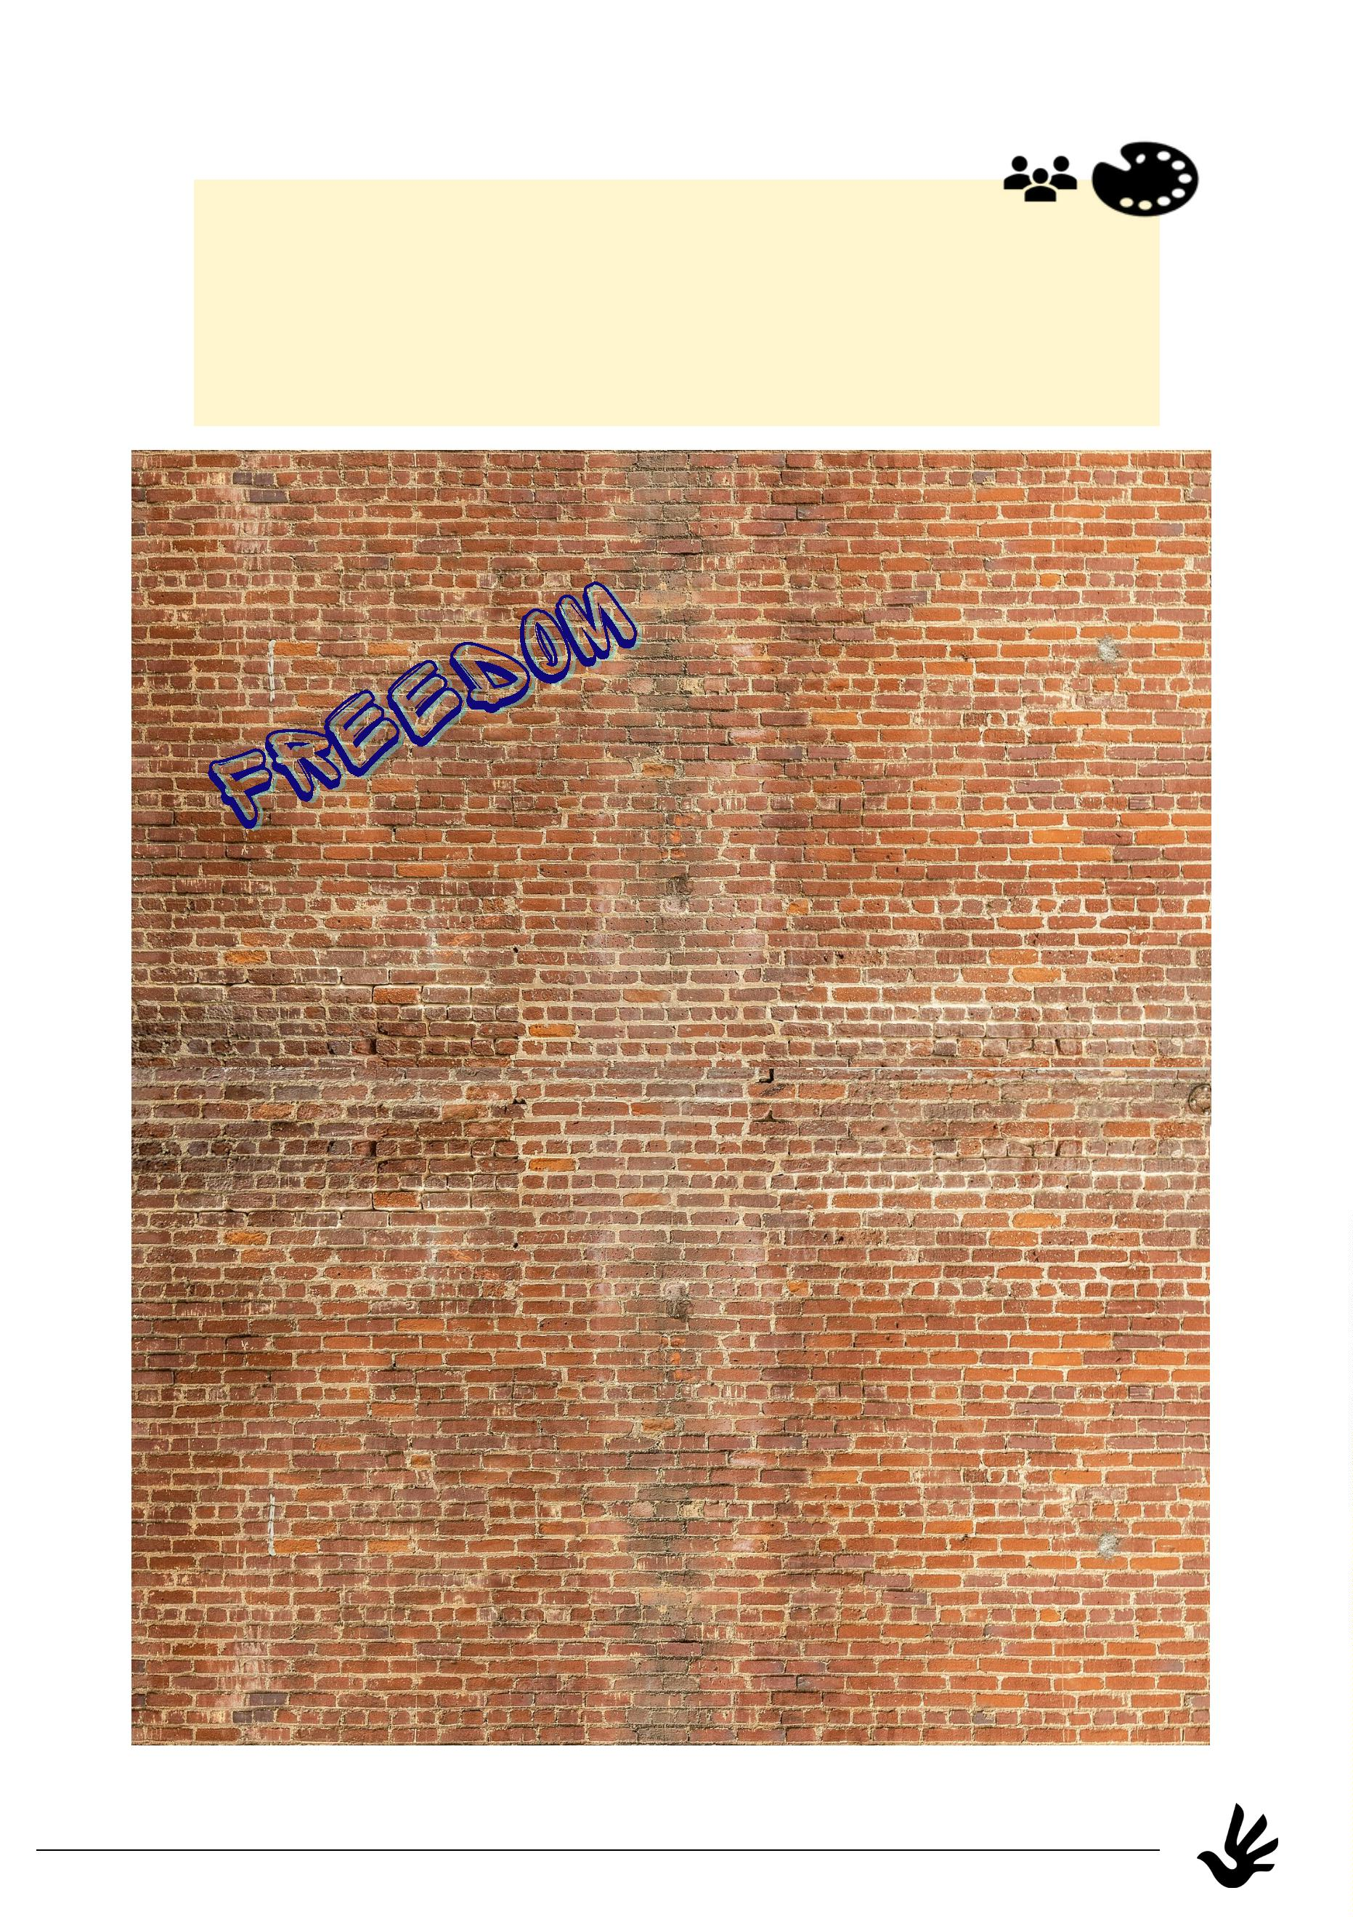

Human Rights in your everyday life
You already got some important information about the 30 articles
of the human rights declaration.
But of course those articles do not only exist on paper, they should be
followed and valid in our everyday life.
What human rights have you already claimed today?
Write them down and find an explanation!
Today I already made use
of the right to....
...because....
Today I already made use
of the right to....
...because....
Today I already made use
of the right to....
...because....
Today I already made use
of the right to....
...because....
9
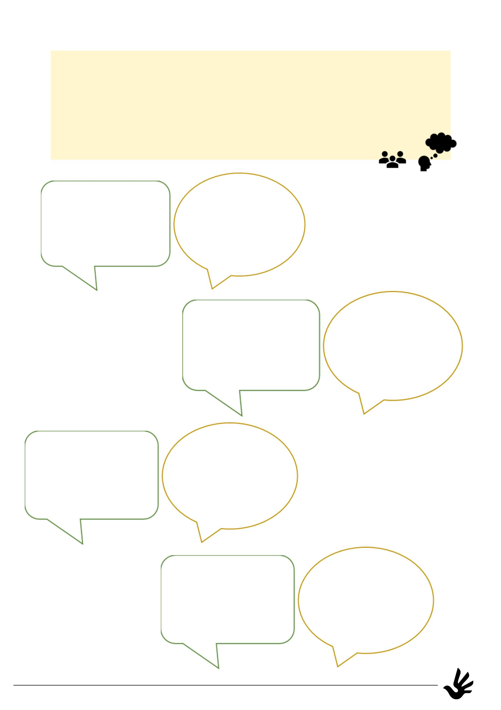

The Fair - An exploration of Human Rights
Follow the QR-Code or link and you will get to know Alex! She will
take you to a fair to explore the Human Rights with you.
Do the tasks she takes you to and deepen your knowledge!
https://thefair-compass.coe.int
Room for your thoughts:
What was something new you learned on the fair?
What shocked you? What inspired you?
10
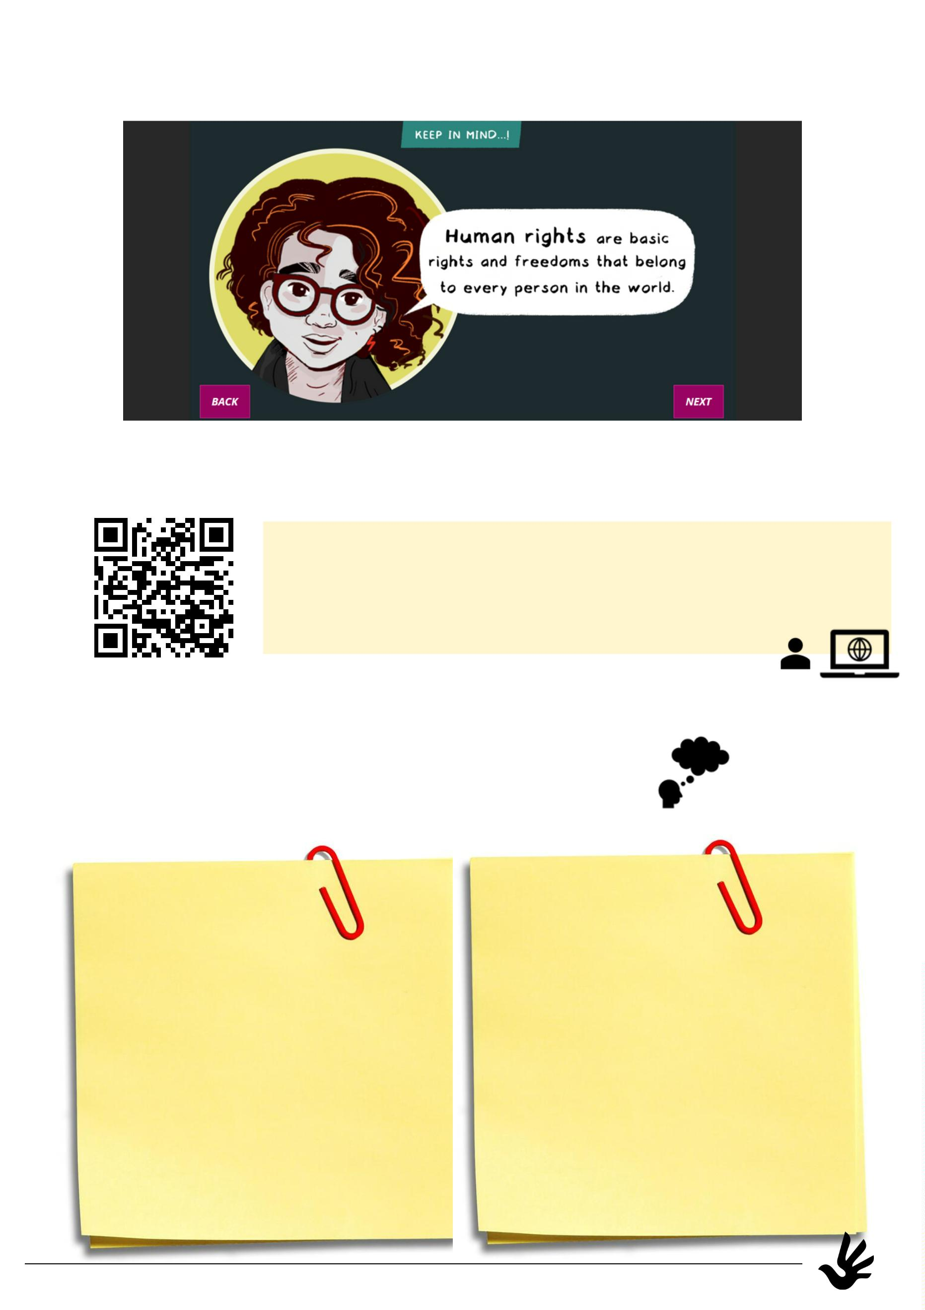

I spy with my little eye...
1
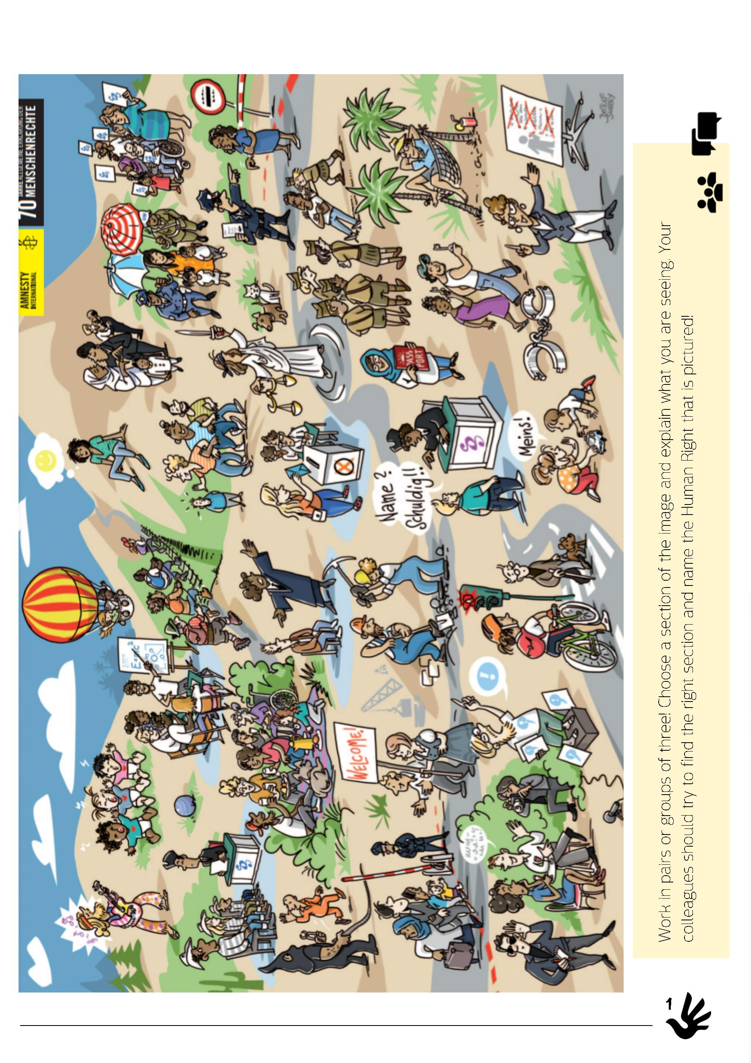

Violation of rights
There are many examples of human rights violations that continue
even today. The use of torture or other inhumane treatment is a
common example. So is the jailing of political opponents simply for
holding peaceful protests against their government, or the
persecution of religious or ethnic minorities.
Take a look at the pictures!
Which human right-keyword from page 4-6 comes to your mind? Write it
under the picture!
1
2
Keyword:__________________________
Keyword:___________________________
3
4
Keyword:___________________________
Keyword:___________________________
12
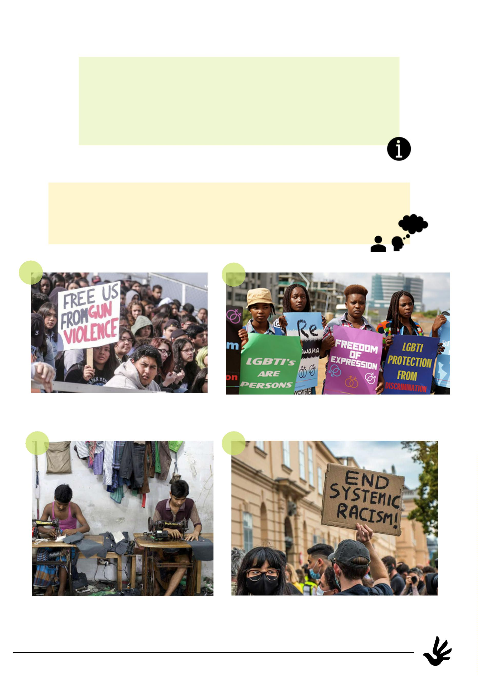

5
6
Keyword:___________________________
Keyword:_______________________________
Choose a picture from above!
Which Human Rights are claimed or violated?
Feel free to discuss your thoughts with a partner!
I choose picture number
I think the violated human right is the right...
In the picture this human right is violated, because ....
Things I can do to protect and not violate human rights
myself are:
1
3
Objective: Raising awareness for violations of rights and social injustices.
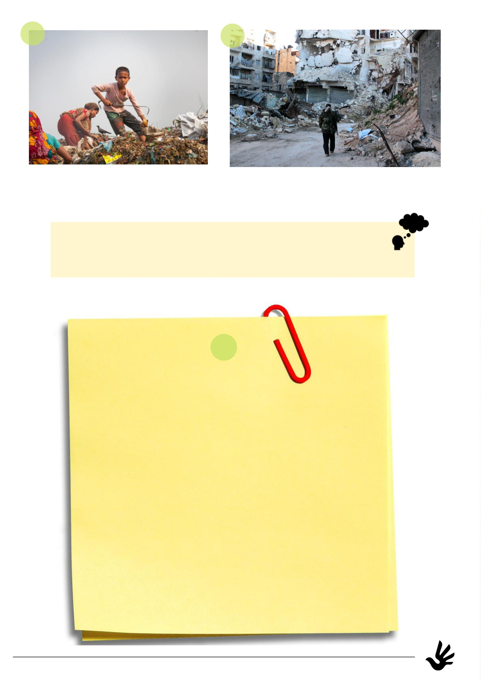

My own Human Rights logo
Down below you see the official Human Rights logo which
is still missing colors!
Create your own logo using many colors or symbols that you associate
with all you have learned. Also fill in some keywords you collected in
this portfolio in different languages!
You can follow the QR-Code or link to see some examples of Human
https://tinyurl.com/
msfefzvm
Rights logos if you need help or inspiration.
1
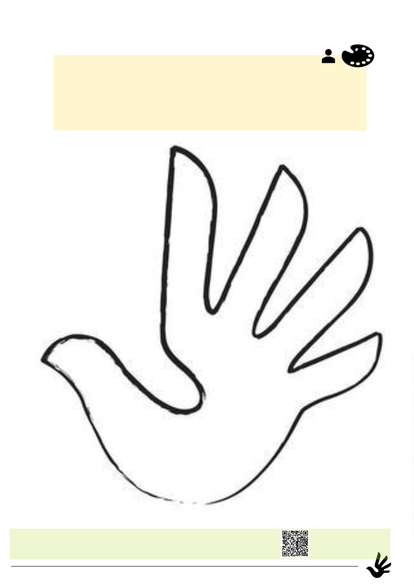

Human Rights in your classroom
Since Human Rights affect every aspect of our life we
have to consider them at school as well.
Are you able to set up some actions towards your classmates or
rules to be followed in your classroom to meet some of the
Human Rights?
Declaration of a human classroom
15
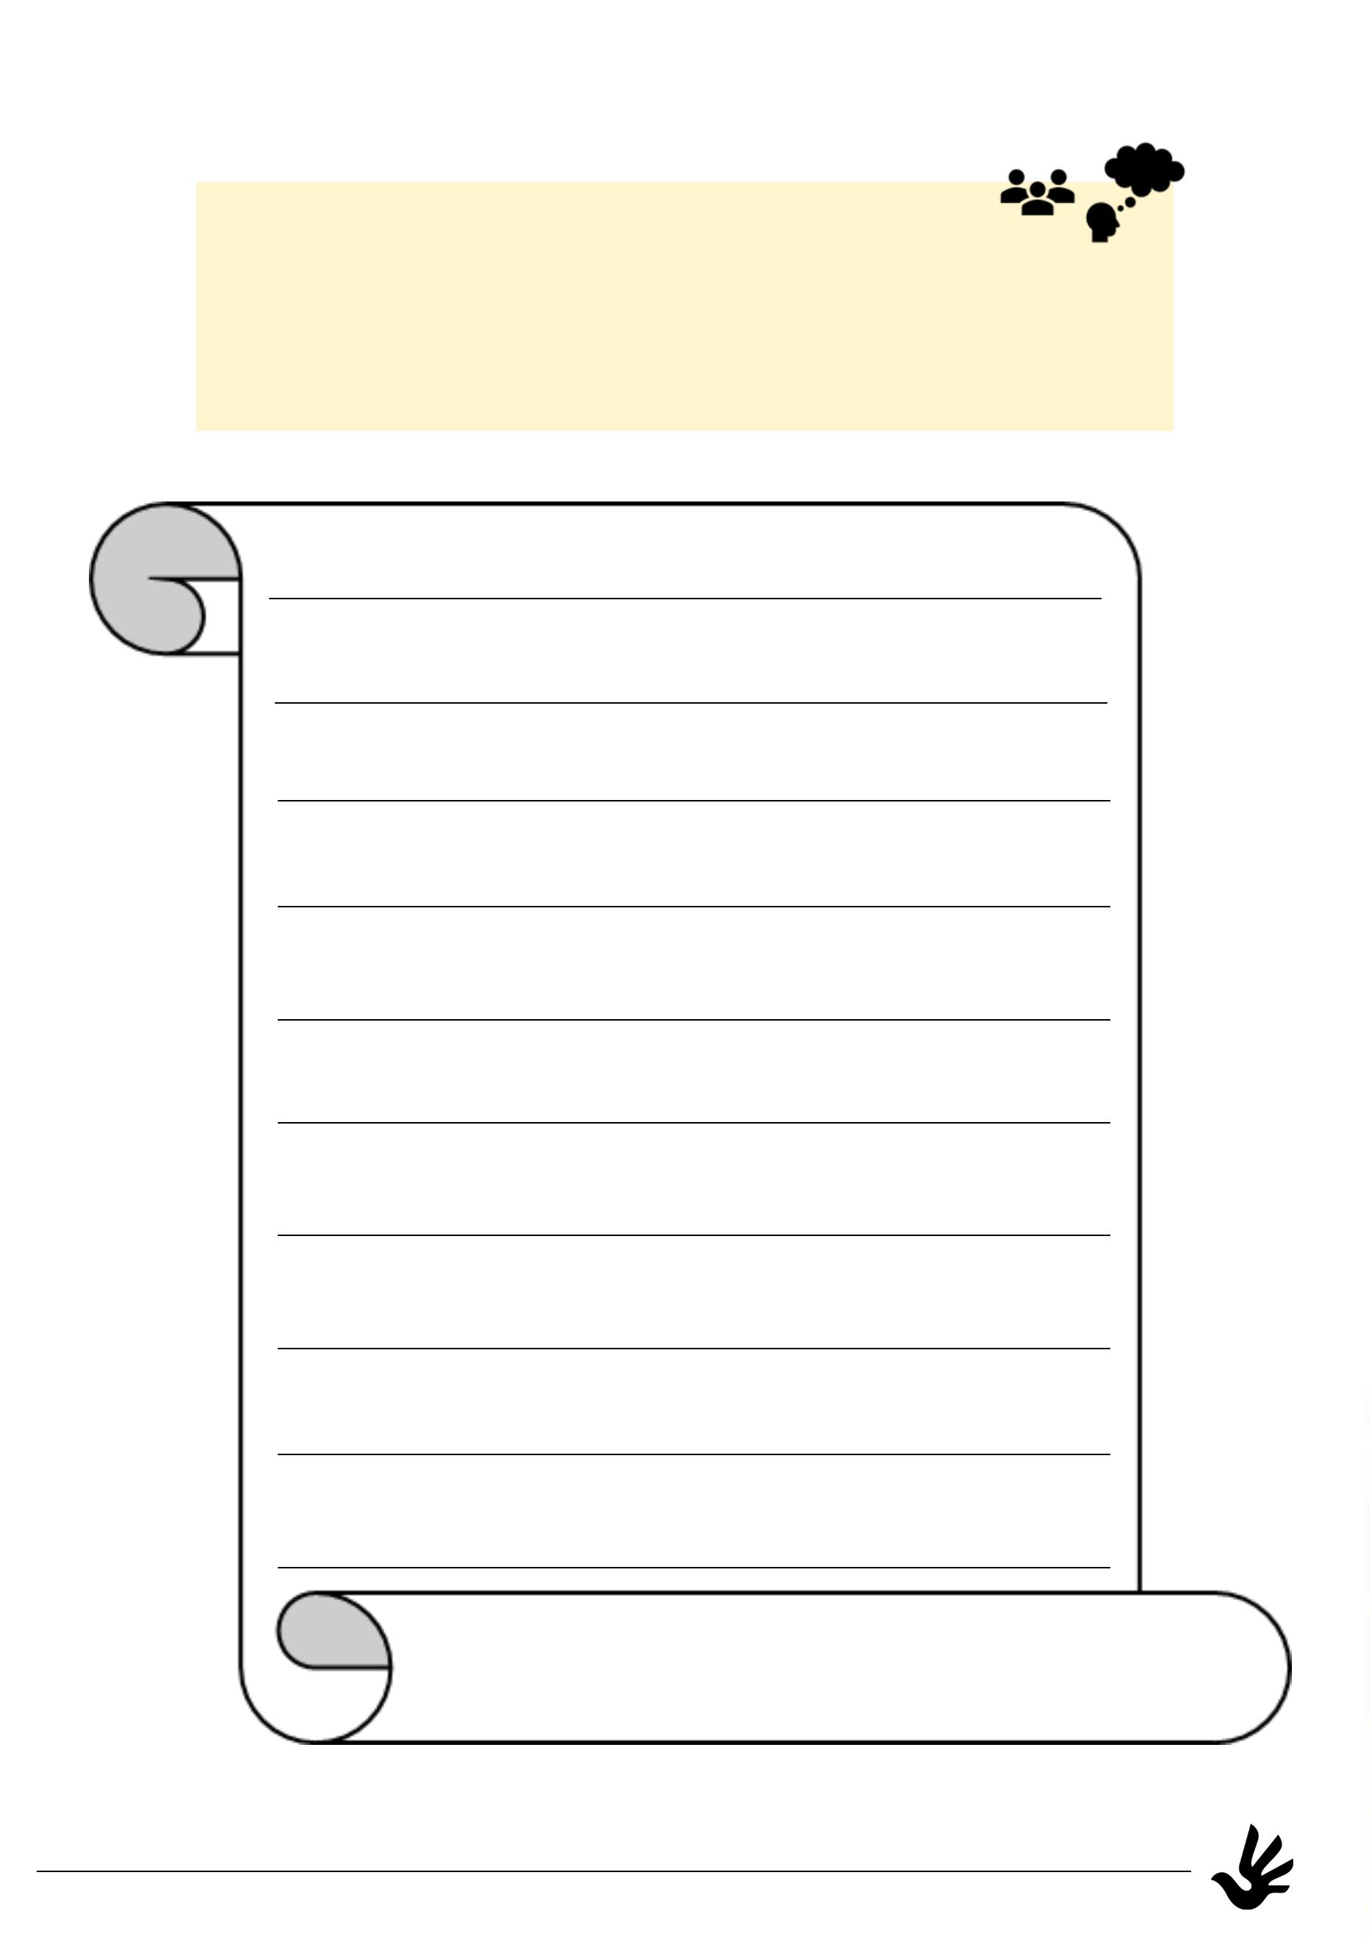

Methodical-didactical preparation and implementation:
The main aspects taken into account in the creation of this portfolio are:
1
.multimodality: the tasks operate on different channels and modalities, such as visual,
verbal and digital contents. The diversification of contents and approaches leads to a
diversified learning experience which achknowledges different types of learners.
2
. reduction of the level of language demand: Texts and instructions are reduced to a
minimum standard to unfold creativity and also to get to know the most important
basic concepts of the topic (i.e. the 30 articles of the HRdeclaration are shortened and
simplified or the use of scaffolding)
3
. multilingualism: to achknowledge the universality of the Human Rights students are
permanently given the chance to integrate their mother tongue or other languages they
speak.
4
. peer-support: to reflect and work on the tasks, students pair up, work in groups or
help each other as councellors (i.e. for their own mother tongue)
5
. connection to families and communities: some of the tasks build an immediate
connection to topics concerning families and communities of the students. The
portfolio itself serves as a tangible point of connection, which students can take home,
show to their parents and discuss the contents with them.
1
6


What do I already know about Human Rights
This exercise is to identify the students' prior knowledge and counts as an assessment.
Students are working individually and try to find associations with the word "Human Rights". Students
have the possibility to work in their mother tongue as well, if some concepts or words are easier
expressed in their first language.
At the end of the assessment the words will be exchanged and collected in the classroom to gain an
overview of the prior knowledge and ideas existing on the topic.
Objective: Raising existing knowledge and reflecting generally on the topic.
Output: word association filled out and completed in plenum
What are Human Rights?
The most informational and theoretical part of the portfolio provides the basic knowledge on the
topic. The information on what the declaration of Human Rights is should come from the teacher as
sort of an introduction to the articles. To understand the articles easier, students are asked to
underline keywords in every article and to write them down in the table. A work in pairs is possible
to discuss key passages and extract the most important words.
Following the QR-Code students can take a look into the translations of the declaration to look for
the keywords in their mother tongue or another language they would like to use for this exercise, to
gain a deeper understanding of the central words and concepts.
The keywords will be discussed in the class together with the teacher.
Objective: Having an overview of the contents of the declaration of Human Rights.
Output: List of keywords in English or the students' mother tongue
Keword pictograms
In order to simplify the content of the articles of the Human Rights declaration once more, students
are choosing an icon, a pictogram for the keywords they found for each article. The website
flaticon.com can be used without creating an account or paying and provides a large database.
Objective: Creating a visual link/support to the single articles and their message.
Output: list of visual links for chosen keywords
Keyword graffiti
Students are asked to create a graffiti wall with keywords they found reading the Human Rights.
They create a lettering on paper and glue it on the brickwall. The individual walls can be displayed in
the classroom and put together for a big keyword graffiti wall.
Objective: Extract keyconcepts and visualize their universality by using different languages.
Output: displayed graffiti wall in classroom
Human rights in everyday life
Since up to this point students got aquainted with the articles of the declaration of Human Rights and
deconstructed them usind the Keywords, pictograms and graffiti wall it is time to transfer them onto
the students everyday life. By using scaffolding (beginning of sentences and separate spaces for the
arguments) students reflect on which Human Right they already claimed today, f.I. I claimed the right
to education, because I am at school. To differenciate the keywords can be used in the green box.
Objective: Transfering Human Rights to everyday life and detect their value.
Output: list of keywords/ Human Rights in the given speech bubbles
1


The fair
To deepen the knowledge and to include some digital content students can visit "The fair" provided by
the European Counsel, where they follow Alex and get to know the declaration of Human Rights in a
more playful and narrative way.
Objective: Deepening knowledge and linking the topic to everyday life.
Output: notes of new knowledge and surprising elements
I spy with my little eye...
In pairs or small groups the students get to observe the hidden picture puzzle provided by Amnesty
International to connect the gathered information with a visual input. Furthermore the students get to
discuss verbally what they see and express the single human rights in their own words which are
visualized in a simplified way in the hidden picture puzzle. Optional students can be divided in groups of
the same mother tongue where they can talk about what they see in their mother tongue using the
keywords they found out in prior exercises.
Objective: Explaining the single articles with a practical/visual example and being able to reproduce them.
Output: having an ongoing conversation about the hidden picture puzzle
Violation of rights
To discuss the crucial aspect of the practical issues connected to the topic students get confronted with
some examples of human rights violations in form of different photographs. After a small introduction a
first reaction to the pictures is captured with a keyword connected to each picture as a placeholder of
the right which is violated.
In the next step students get to choose one pictures and reflect on it with the help of scaffolding, which
means the beginnings of the sentences are given in the short reflection protocol.
Objective: Raising awareness for violations of rights and social injustices.
Output: list of possible violations and their explanations, list of solutions
My own Human Rights logo
To combine all the different elements gathered by now students are asked to design their own human
right logo. The official logo (combination of hand and a peace dove) is first discussed together. Then
every student fills in keywords, pictograms, little drawing etc. to create an individual logo. This exercise
is also suitable for an art lesson.
Objective: Visualizing the elements and the universality of Human Rights.
Output: finished logo displayed in the classroom
Human Rights in your classroom
The declaration of a human classroom can be seen as a final project which includes the major
elaborated aspects. In different articles students should be able to bring forward some ideas on how to
transfer the human rights declaration on the classroom setting and the social life happening at school.
The process can be held in a plenary brainstorming session, a group work or an individual work where
the ideas are discussed and collected later to agree on the most important or most produced articles.
The keywords can be used as a starting point.
Once agreed on a number on articles, the declaration of a human classroom can be captured on a class
poster and completed by the single logos created by the students of the class.
Objective: Transfering Human Rights to everyday life and detect their social value.
Output: poster with the declaration of a human classroom
1
8


Sources:
Coverphoto:
www.freepik.com/vectors/human-rights
Hidden picture puzzle (page 11):
https://www.amnesty.de/sites/default/files/2020-09/Wimmelbild-Poster-Allgemeine-Erklaerung-
der-Menschenrechte-September-2020.pdf
Human Rights logo (page 14):
https://en.paperblog.com/human-rights-logo-competition-winner-free-as-a-man-70680/
Post-it for thoughts (page 10, page 13):
http://clipart-library.com/clipart/LcdoqpLni.htm

1
9


